**Feature: Booking Appointments**

The booking appointments feature is meant for patients to make appointment requests with doctors at the hospital. After a patient logs in he is redirected to the patient dashboard where he can click on a link called ‘Appointments’. Here he can view upcoming appointments, make a request for an appointment and view request pending requests.

This feature will have an administrative backend managed by the doctor’s admin and the super admin. The super admin has the same rights as the doctor admin. Admins can log in into the website and send replies to requests from the patients. The admin can also create an appointment.

The database will look like this:

|  |  |
| --- | --- |
| AppointmentID | Numeric – Primary Key |
| Patient ID | Varchar |
| Patient Name | Text 100 characters |
| Doctor Name | Text 100 characters |
| Reason | Text 255 characters |
| Appointment Date | Date |
| Appointment Time | DateTime |
| Request made Date | Date |
| Request Status | Text 100 characters |

**The data flow models:**

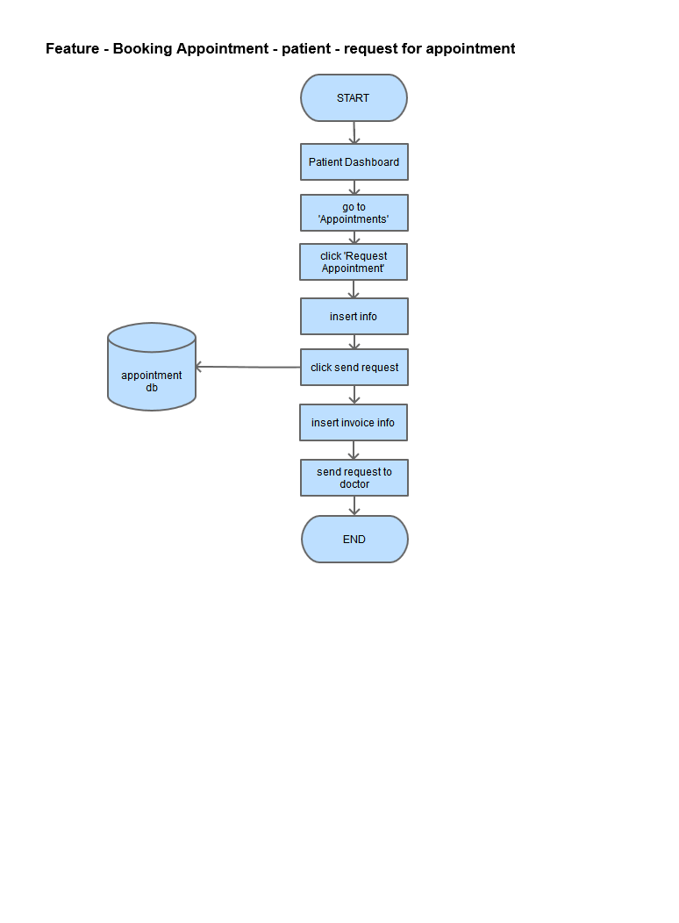

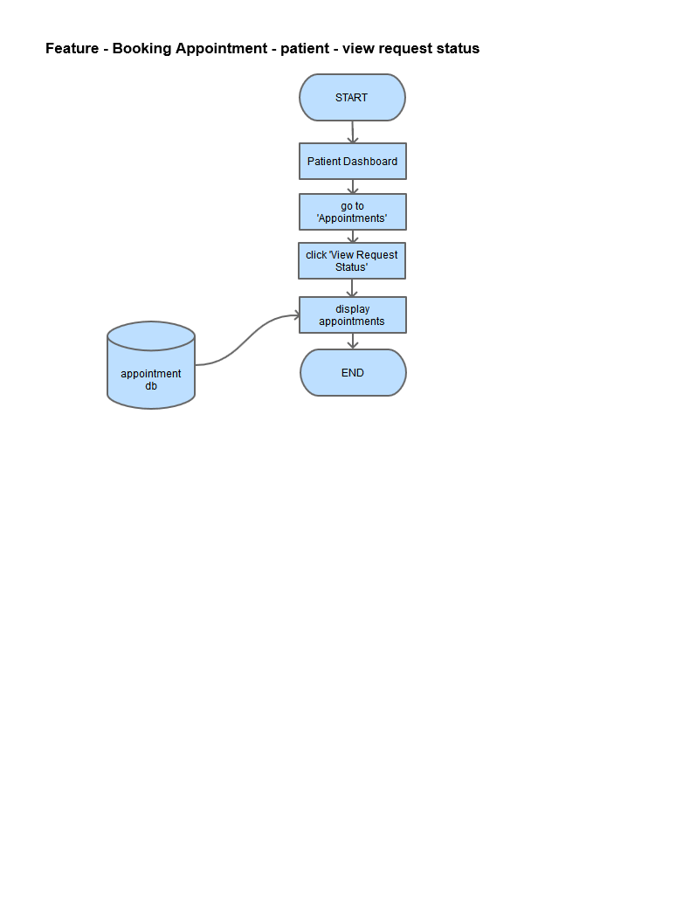

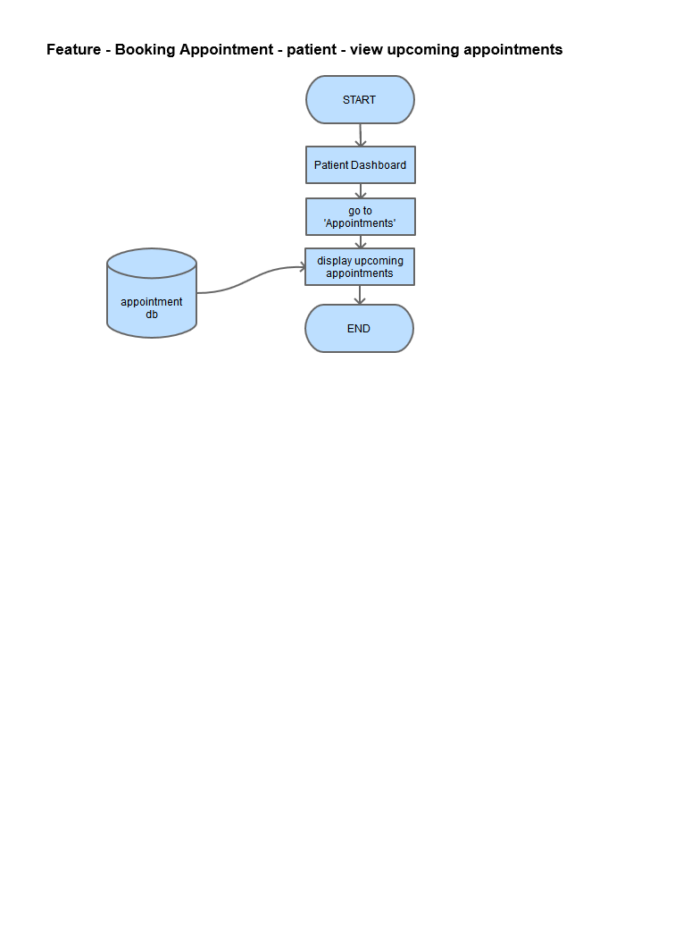

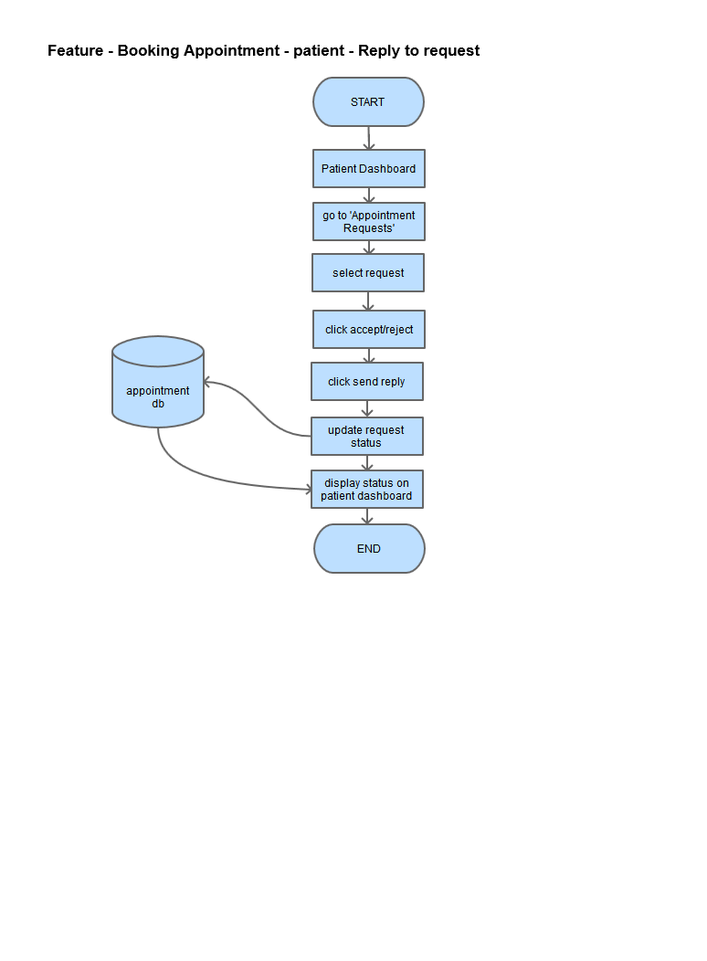

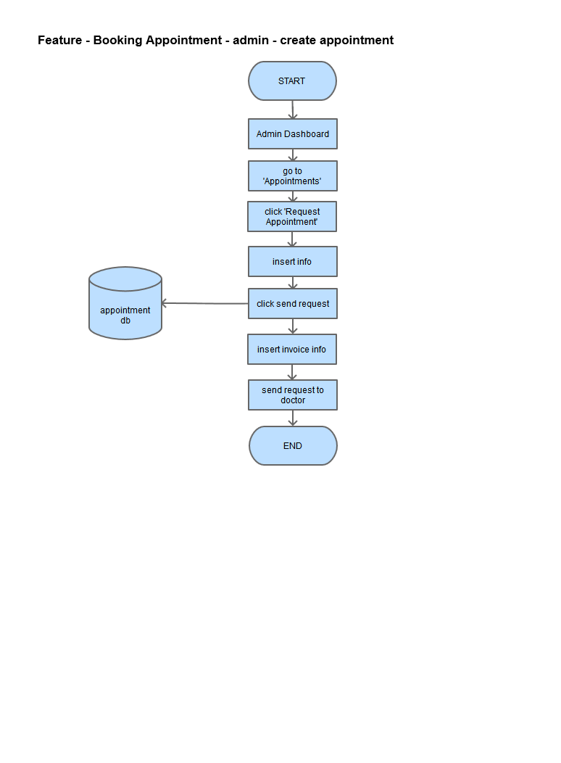



**Wireframes:**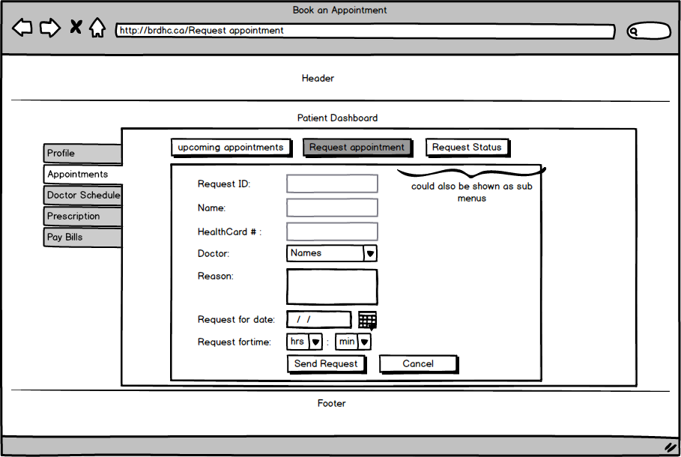



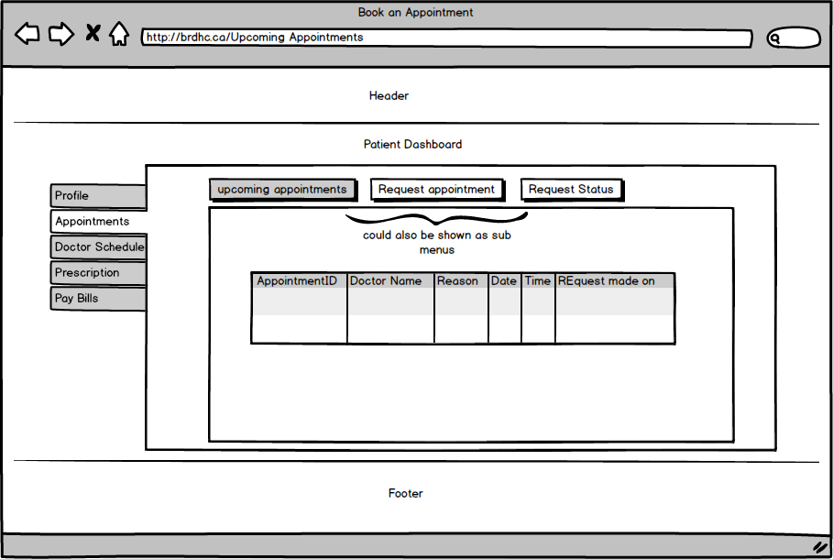

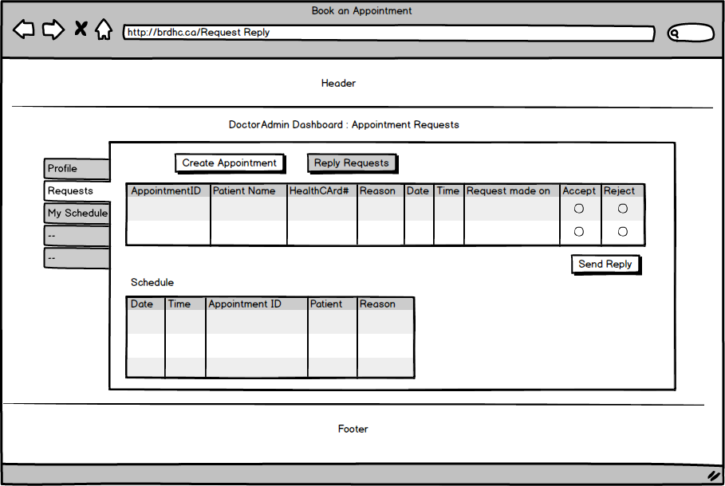

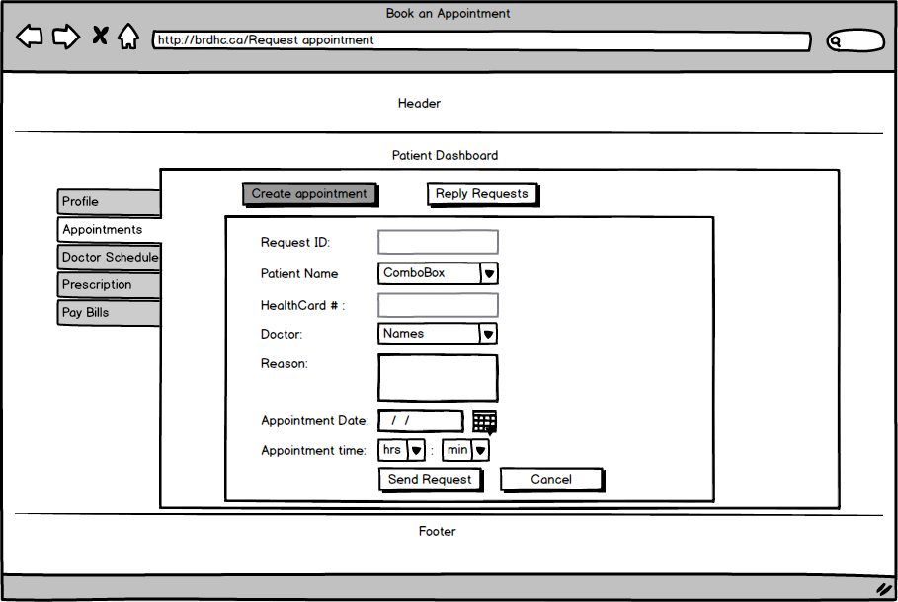

**Feature: Emergency Wait Time**

The emergency wait time helps the patient identify the wait time at the emergency unit of the hospital. The patient needs to log in to know the wait time.

The emergency unit admin can update the wait time. Default wait time is 15 min. The super admin can also update the emergency wait time.

The database looks like this:

|  |  |
| --- | --- |
| EmergencyID | Numeric – Primary Key |
| Time | DateTime |
| Date | Date |
| UpdatedBy | Text 100 characters |

**The dataflow diagrams:**

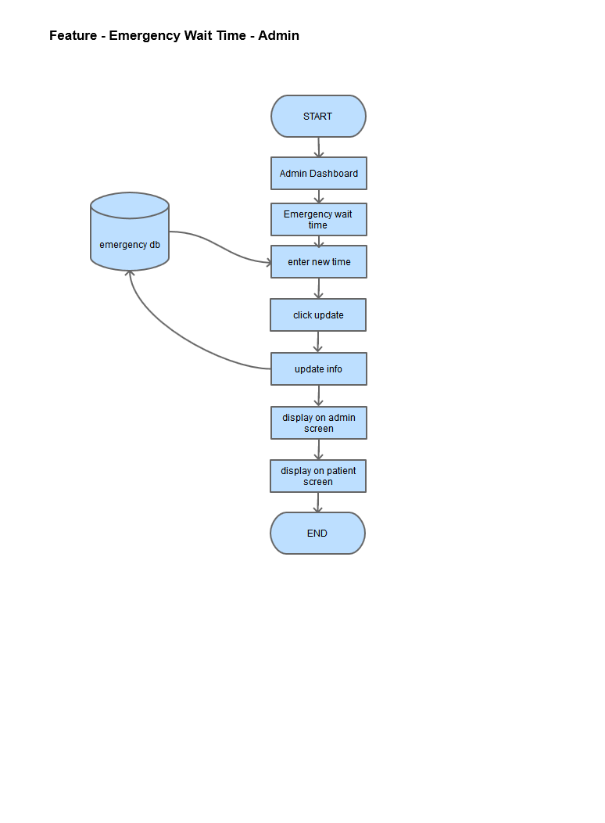

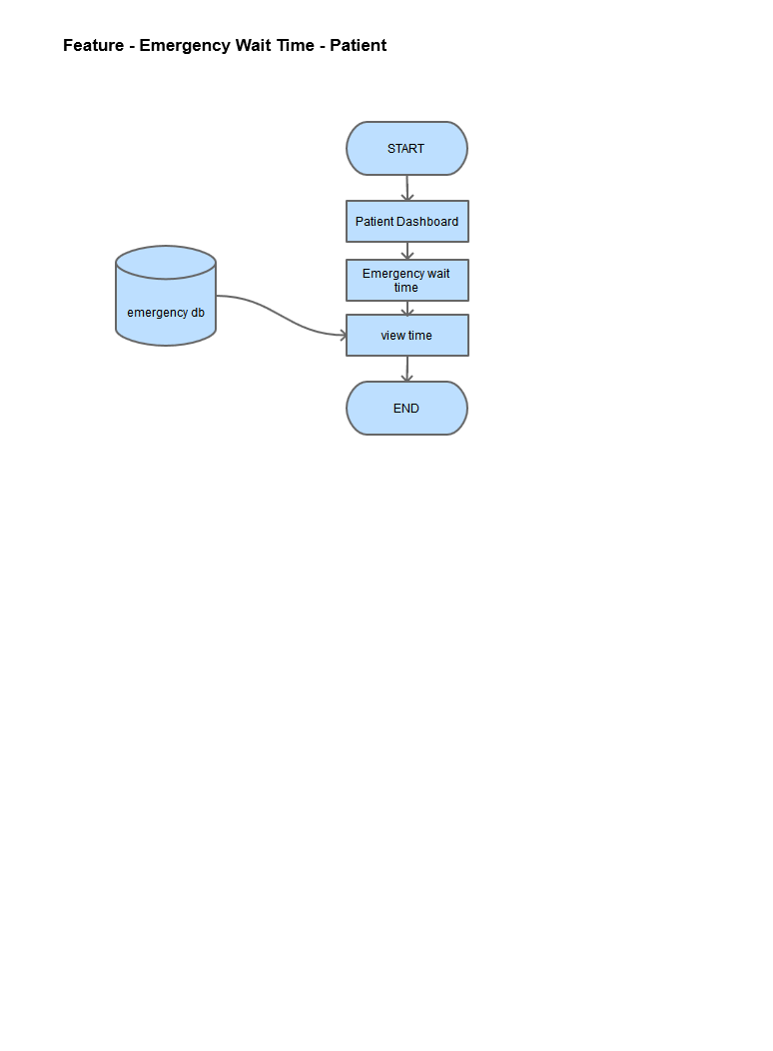

**Wireframes:**

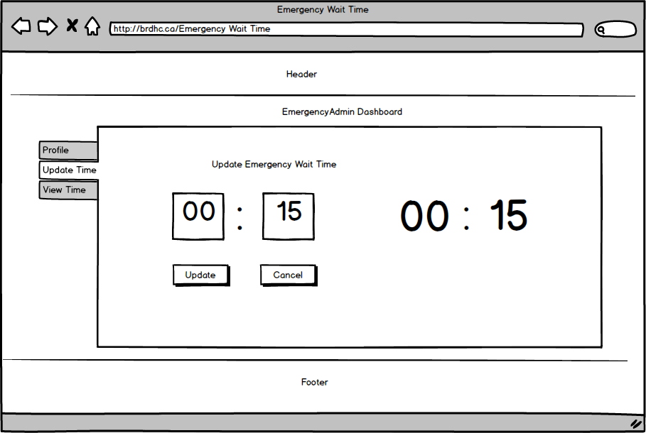

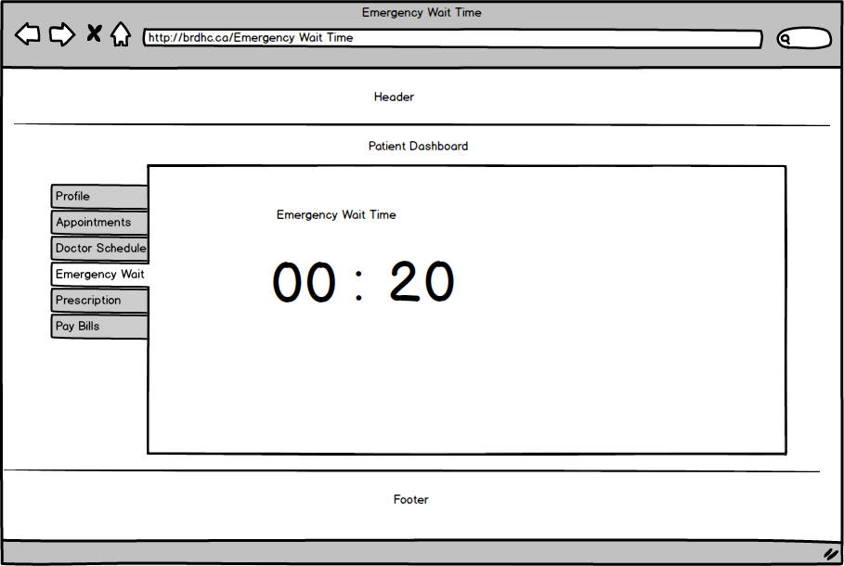

**Feature: Pay Bills**

In case of any payments to be made by the patient, like medicines or treatment not covered by insurance, the patient can use this feature and make an online payment.

The admin must create an invoice for the patient. The patient can then verify the invoice and pay the charges. The admin can also update and delete an invoice.

The database looks like this:

|  |  |
| --- | --- |
| Invoice ID | Numeric – Primary Key |
| Patient ID | Varchar |
| DoctorAdmin ID | Varchar |
| Total Amount | Numeric |
| CreatedDate | Date |
| DueDate | Date |
| PaidDate | Date |
| PaymentStatus | Text 100 characters |

**The dataflow diagram:**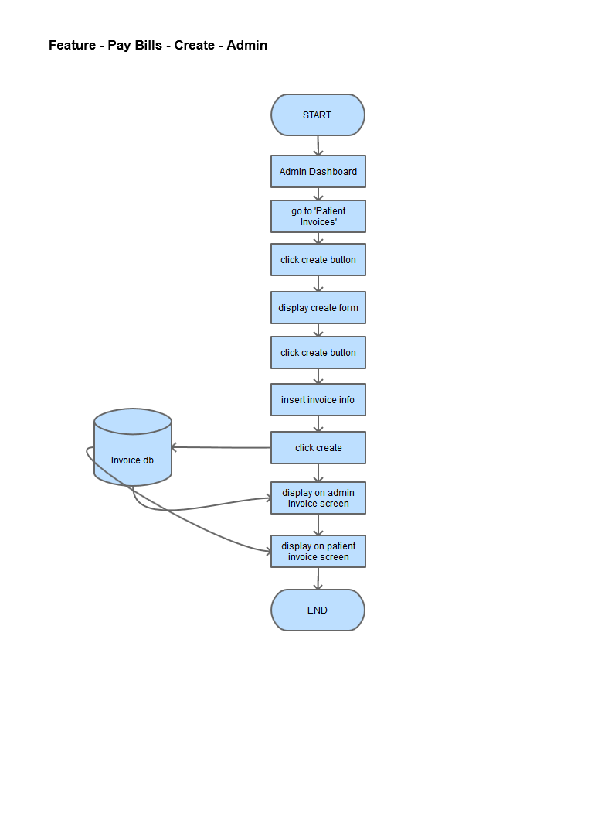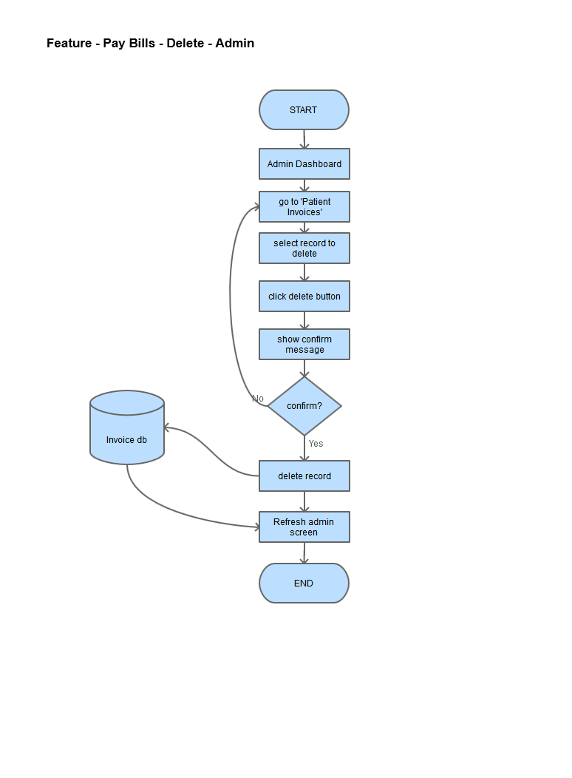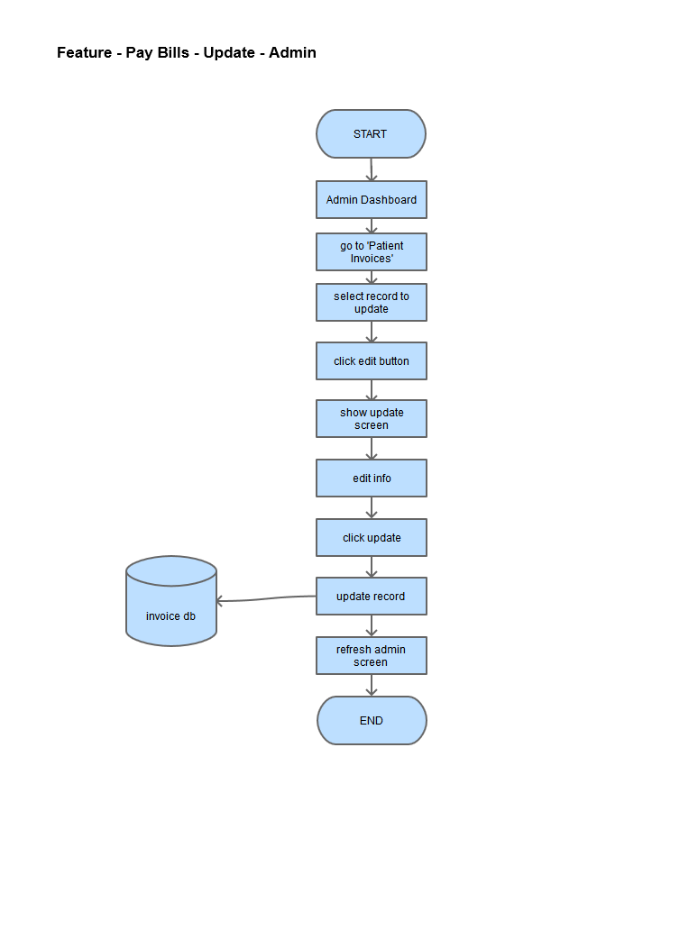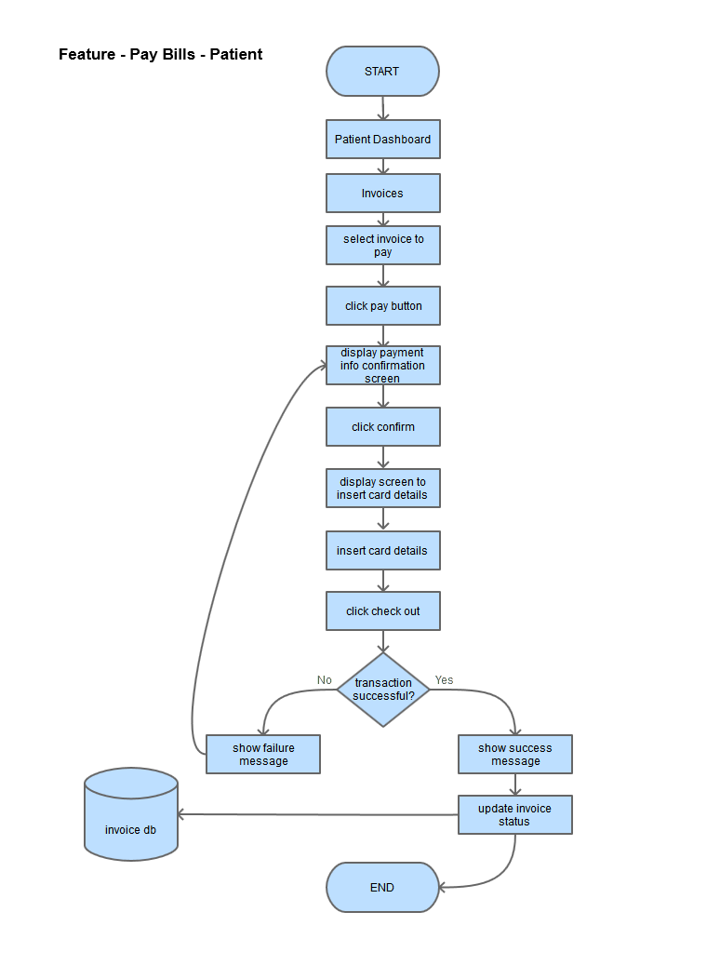

**Wireframes:**

